1. 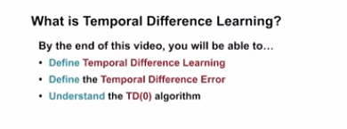
2. .Predicting guess from a guess
3. .
4. In the prediction problem, our goal is to learn a value function that estimates the returns starting from a given state
5. .
6. 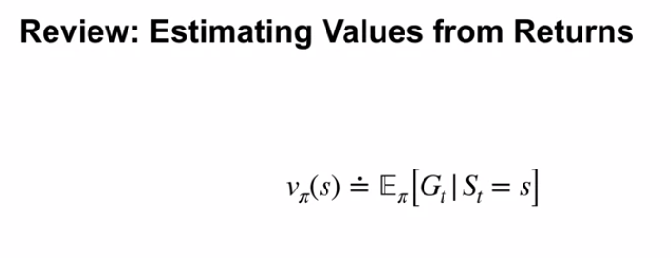
7. .
8. 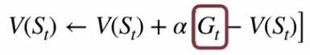.
9. Before we get started, let's discuss a small modification to our Monte Carlo policy evaluation method. We can use this formula to incrementally update our estimated value. Notice that this uses a constant step size like our bandit learning algorithms. That means this algorithm can form a Monte Carlo estimate without saving lists of returns. To compute the return, we have to take samples of full trajectories. This means we don't learn during the episode, but we want to be able to learn incrementally before the end of the episode.
10. .
11. .
12. 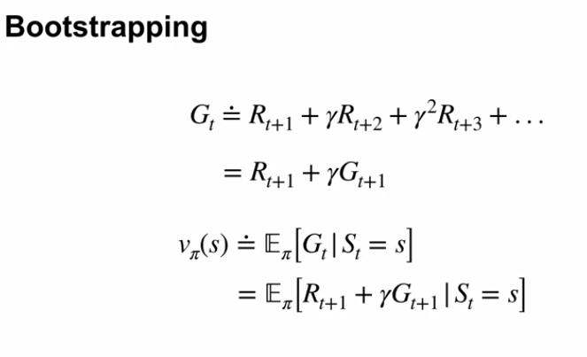
13. .
14. .
15. 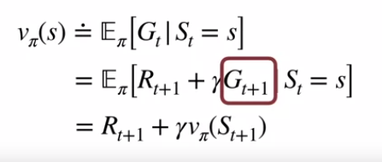
16. .
17. .
18. 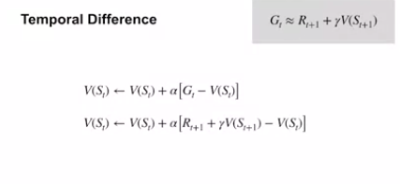
19. .
20. .
21. We don’t wait to update next episode.we update at every step
22. . 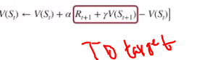
23. .
24. 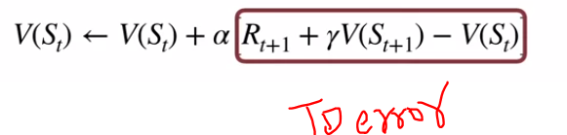
25. .
26. .
27. 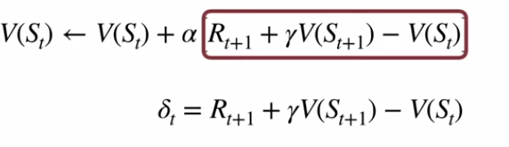
28. .
29. .
30. How to get next state from environment ????
31. 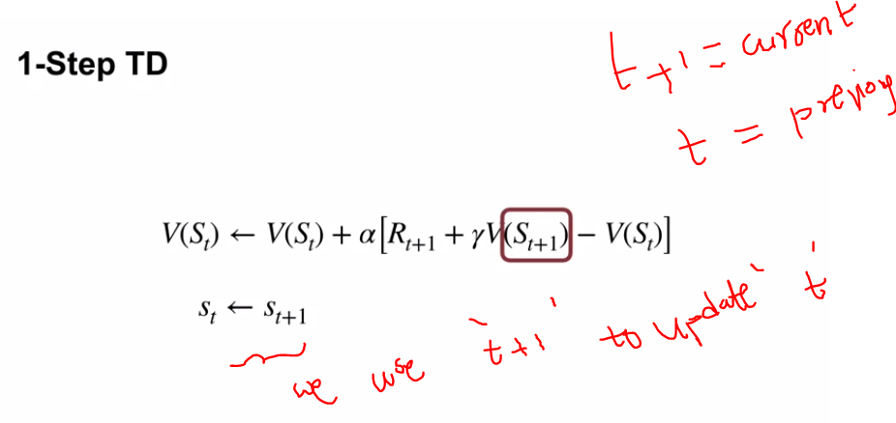
32. .
33. 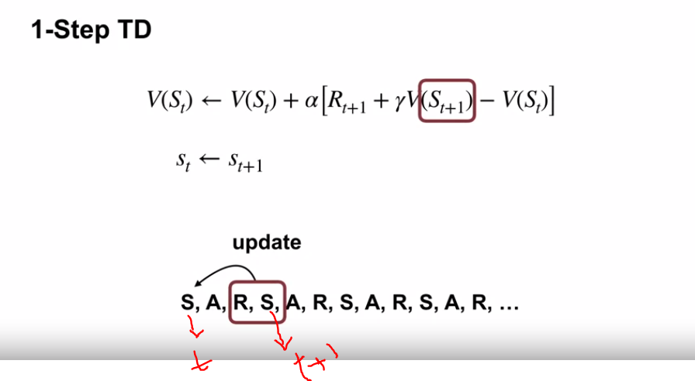
34. .
35. 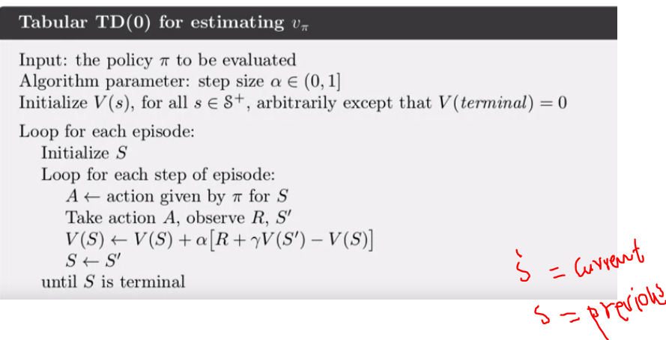
36. .
37. .
38. 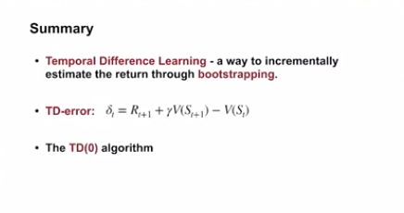

Richard sutton

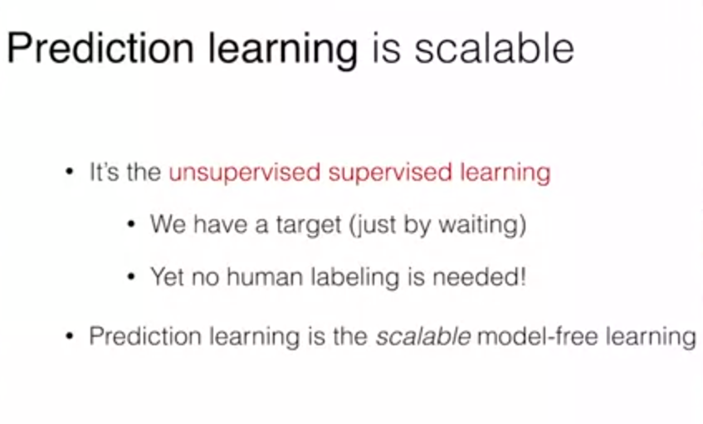

1. 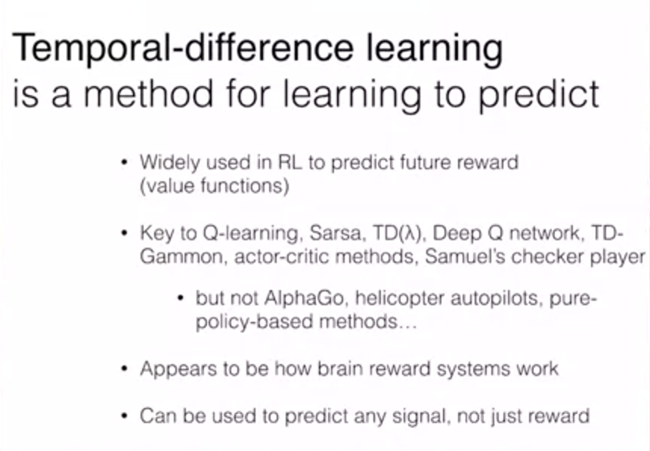
2. .
3. 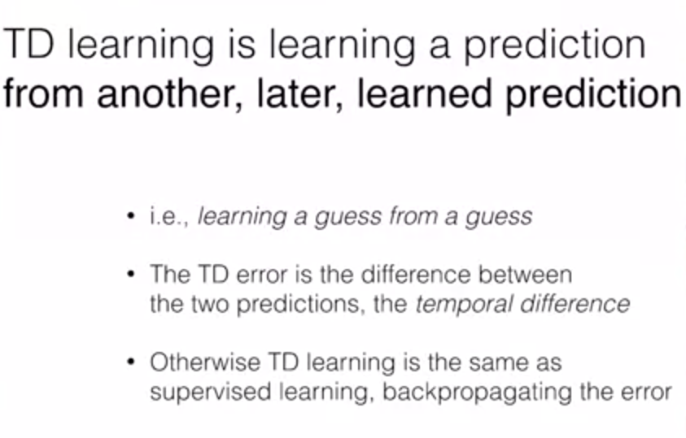
4. .
5. .
6. 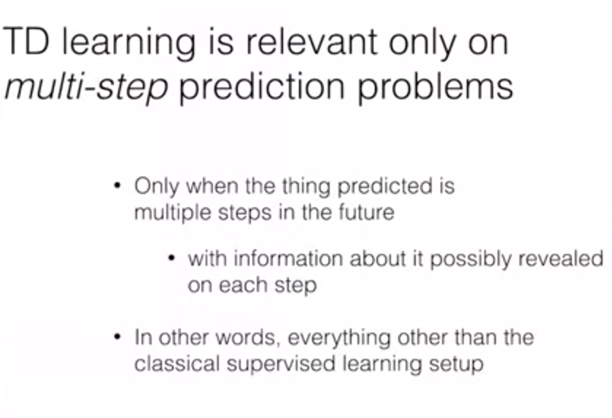
7. .
8. .
9. 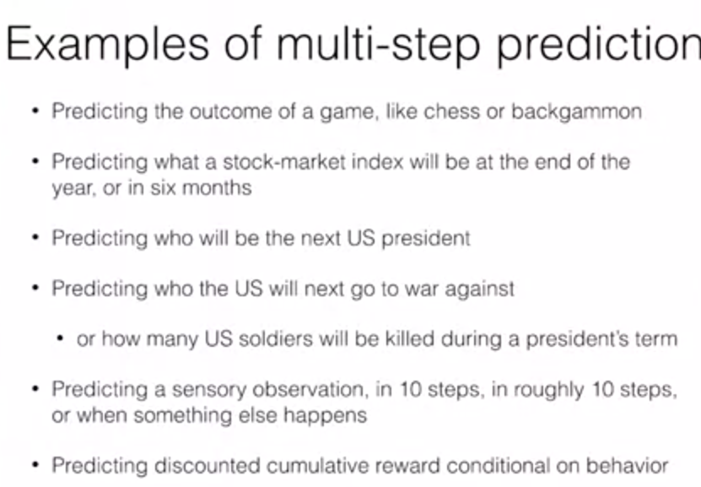
10. .
11. .
12. 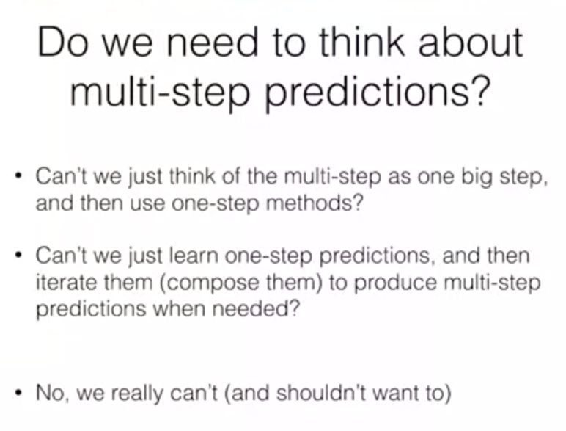
13. .
14. .
15. 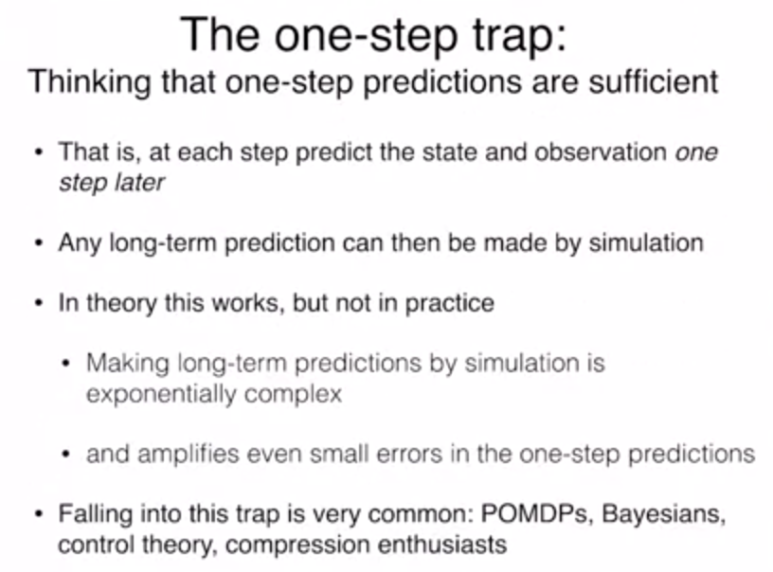
16. .
17. .
18. 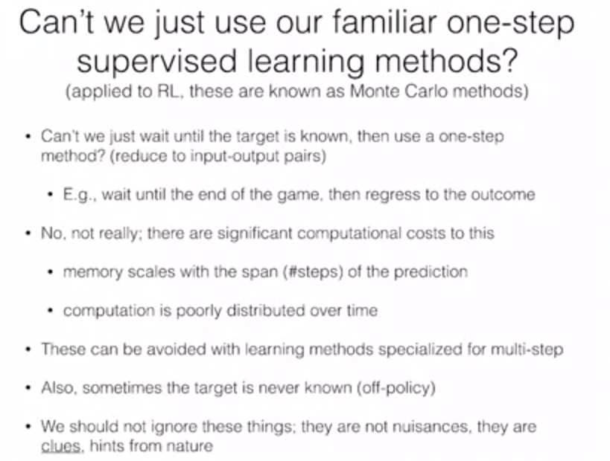
19. .
20. .
21. 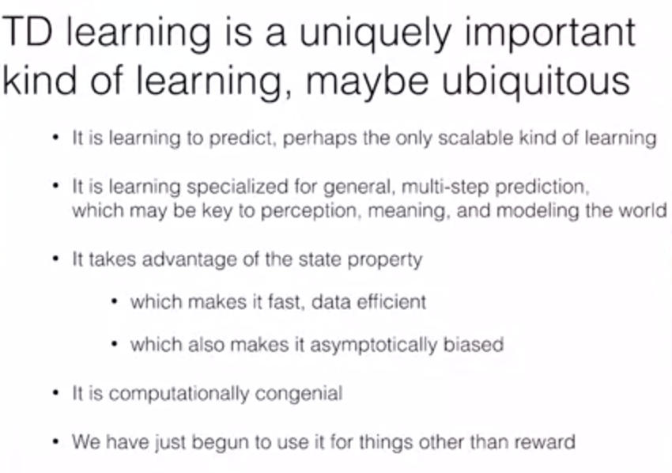
22. .
23. .

Points:

1. TD doesn't need to wait till the end of episode unlike MC, which may scale to large memory for very long episodic tasks.
2. Temporal Difference seems to more naturally capture the dynamics of **how we continuously learn** as we receive rewards (or lack of them) than methods like Monte Carlo, where learning only happens at the end of an episode.
3. I find its **association with dopamine**, as internal reward of our brains, most inspiring as well, and can't see how we could disregard these hints from nature to make progress in AI.
4. On the other hand, animals with high cognitive levels seem to also frequently follow a different dynamics when, after some reward, we **reflect on what went wrong/right** to review our assessments (≈value-functions). This certainly has an effect on our behaviour, often long time after the actual states and rewards were experienced, which seems to follow a more "pseudo-episodic" learning pattern.
5. Monte Carlo needs to wait until the end of the episode, which can be too long for the brain.
6. It seems more likely that the brain might do short term corrections instead of waiting a long time and only correcting at the end.
7. 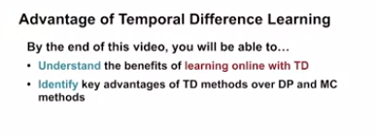
8. .
9. 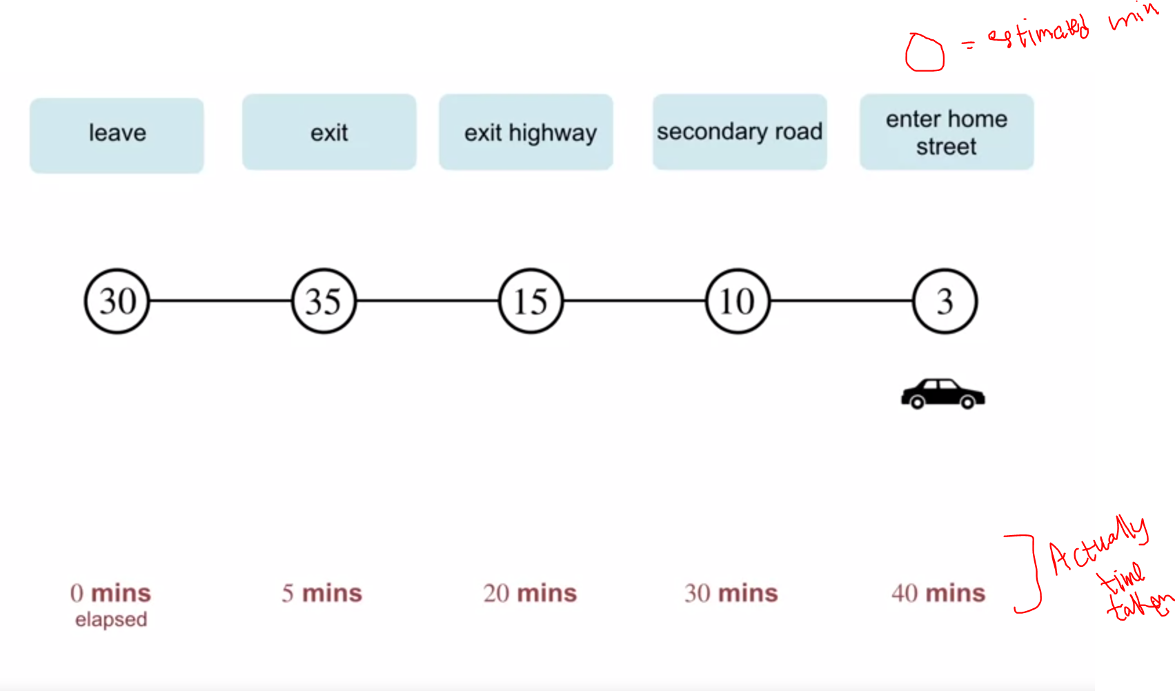
10. .
11. .
12. 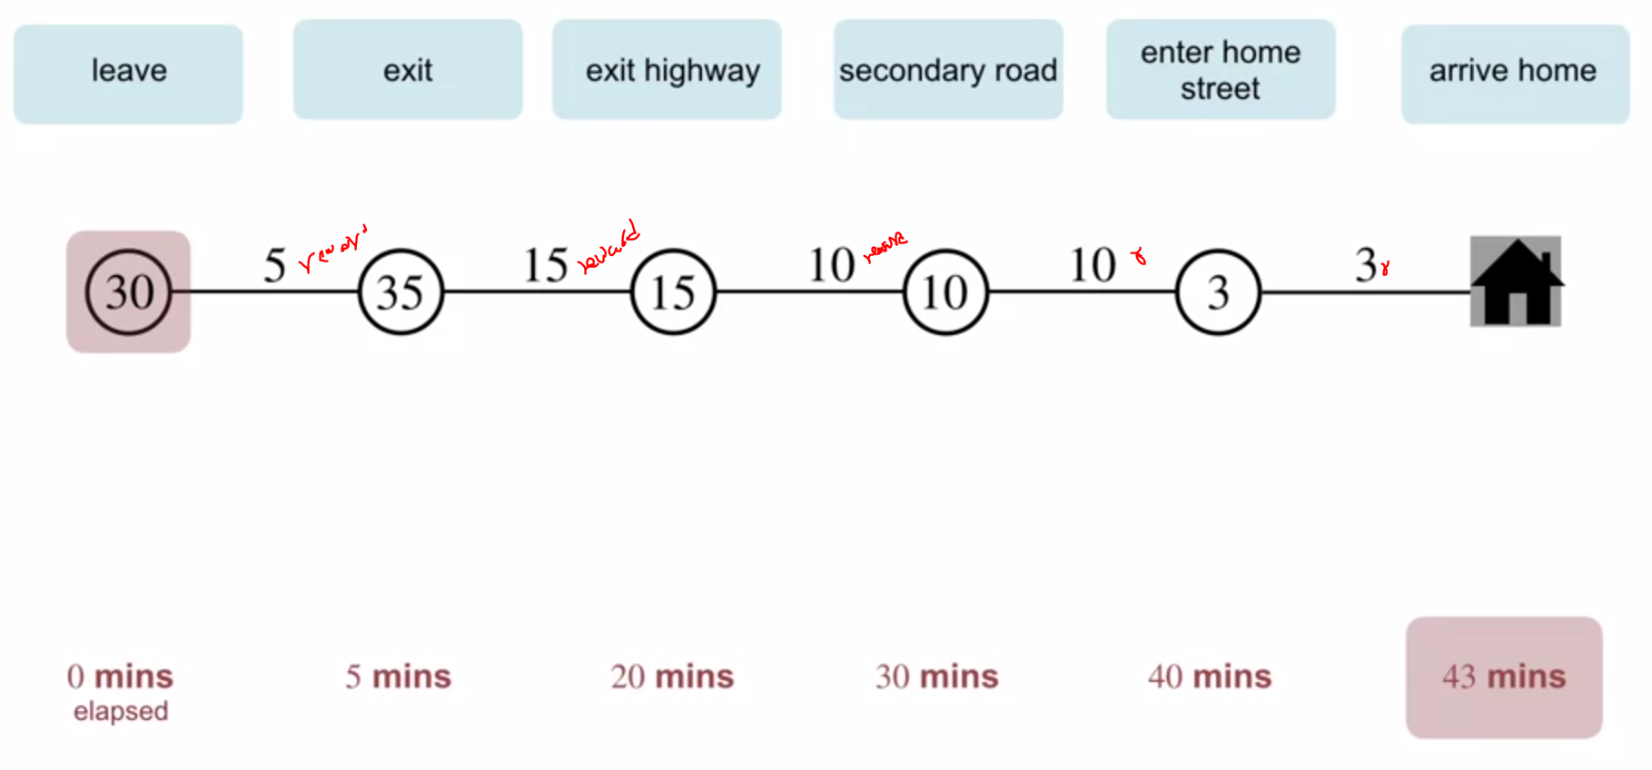
13. .
14. .Lets do Monte Carlo V(s) update
15. .
16. 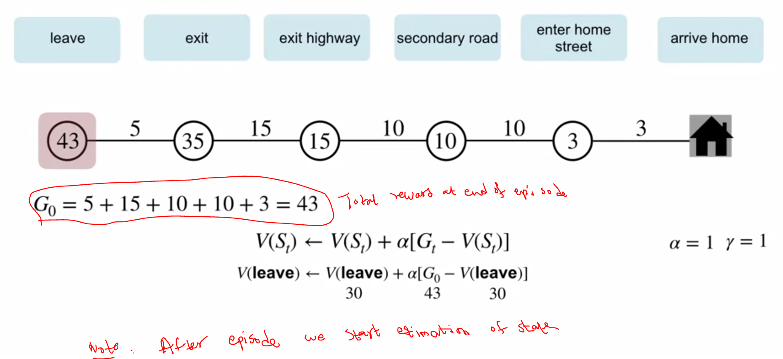
17. .
18. .
19. .
20. 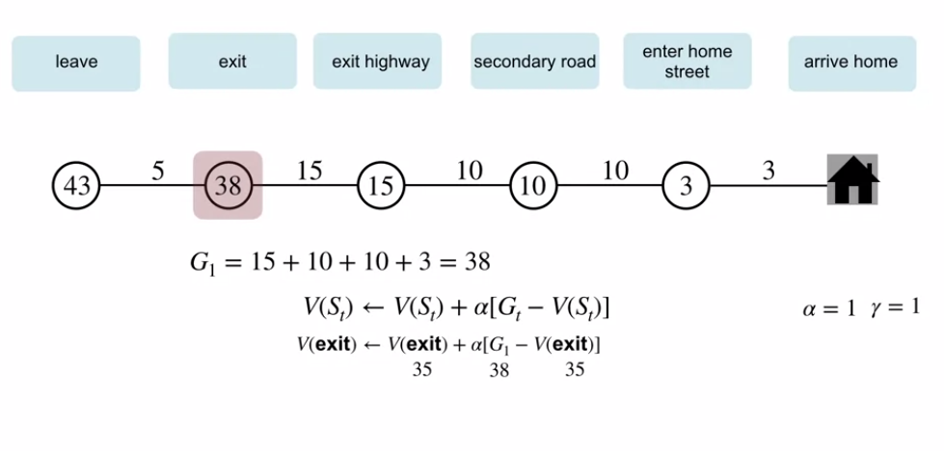
21. .
22. 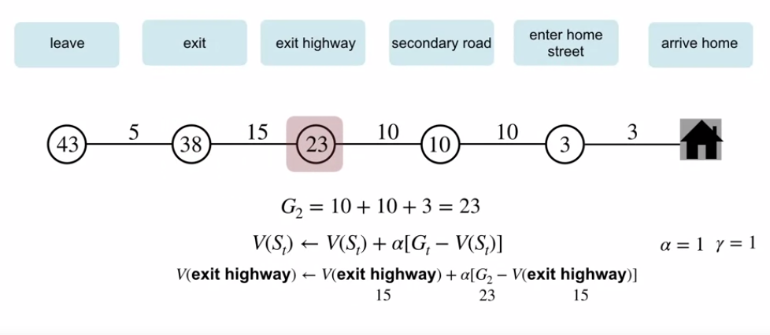
23. .
24. .
25. .Lets do TD learnign V(s) update
26. .
27. .
28. 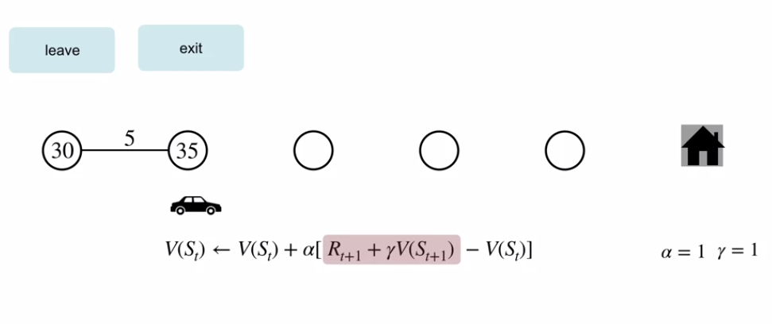
29. .
30. .
31. 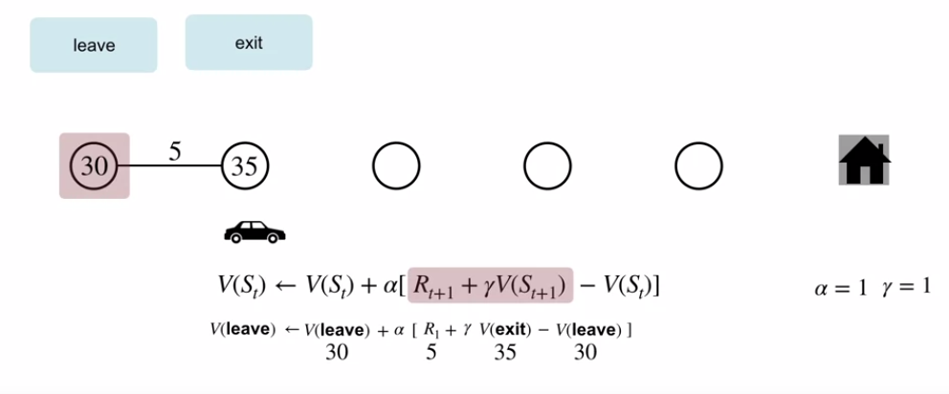
32. .
33. .
34. .
35. 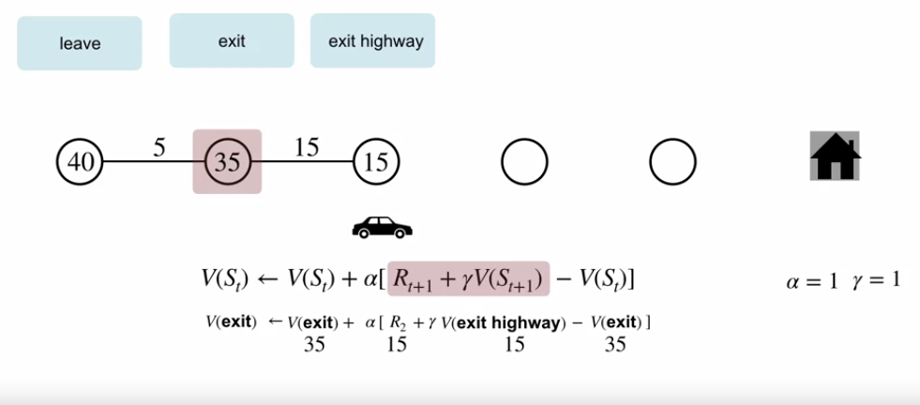
36. .
37. .
38. 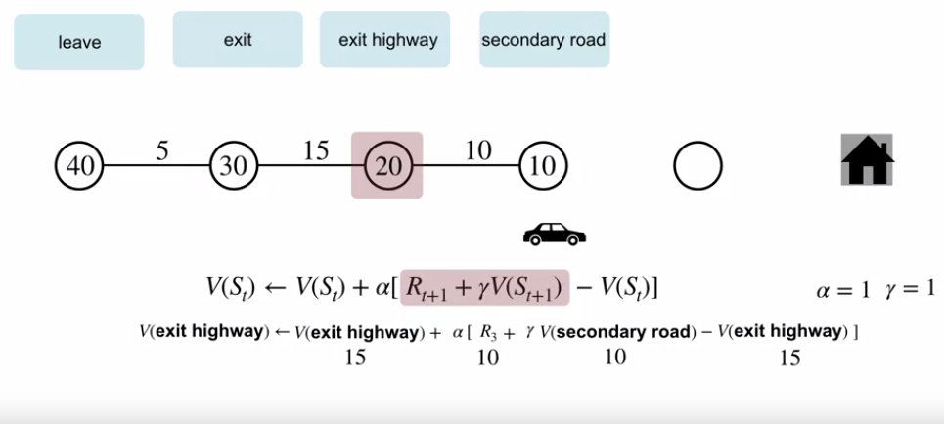
39. .
40. .
41. .
42. 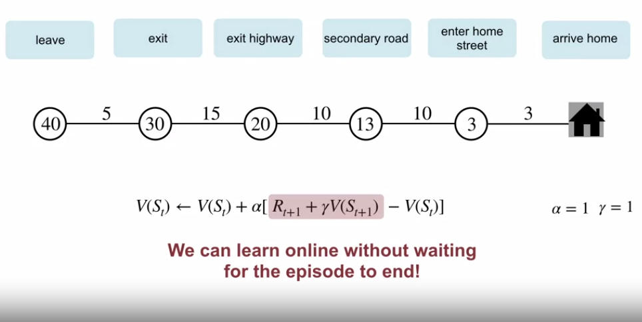
43. .
44. .
45. 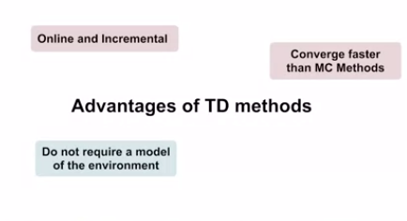
46. .
47. Evaluate TD vs MC
48. .
49. 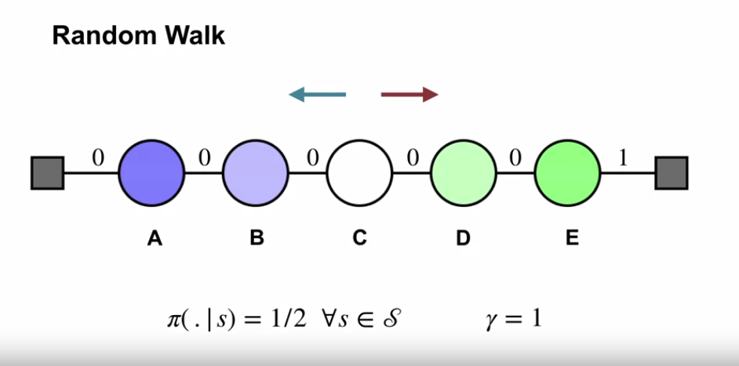
50. .
51. .
52. The value of each state is the probability terminating on the right when starting from each state. The value of the start state is 0.5, that means the probability of terminating from the center is a half. Randomly wandering from the center has a 50-50 chance of terminating on either side. That makes sense. The value of each state is the probability terminating on the right when starting from each state. The value of the start state is 0.5, that means the probability of terminating from the center is a half. Randomly wandering from the center has a 50-50 chance of terminating on either side. That makes sense.
53. .
54. .Lets run experiments of TD,MC and compare with true values
55. .
56. .
57. 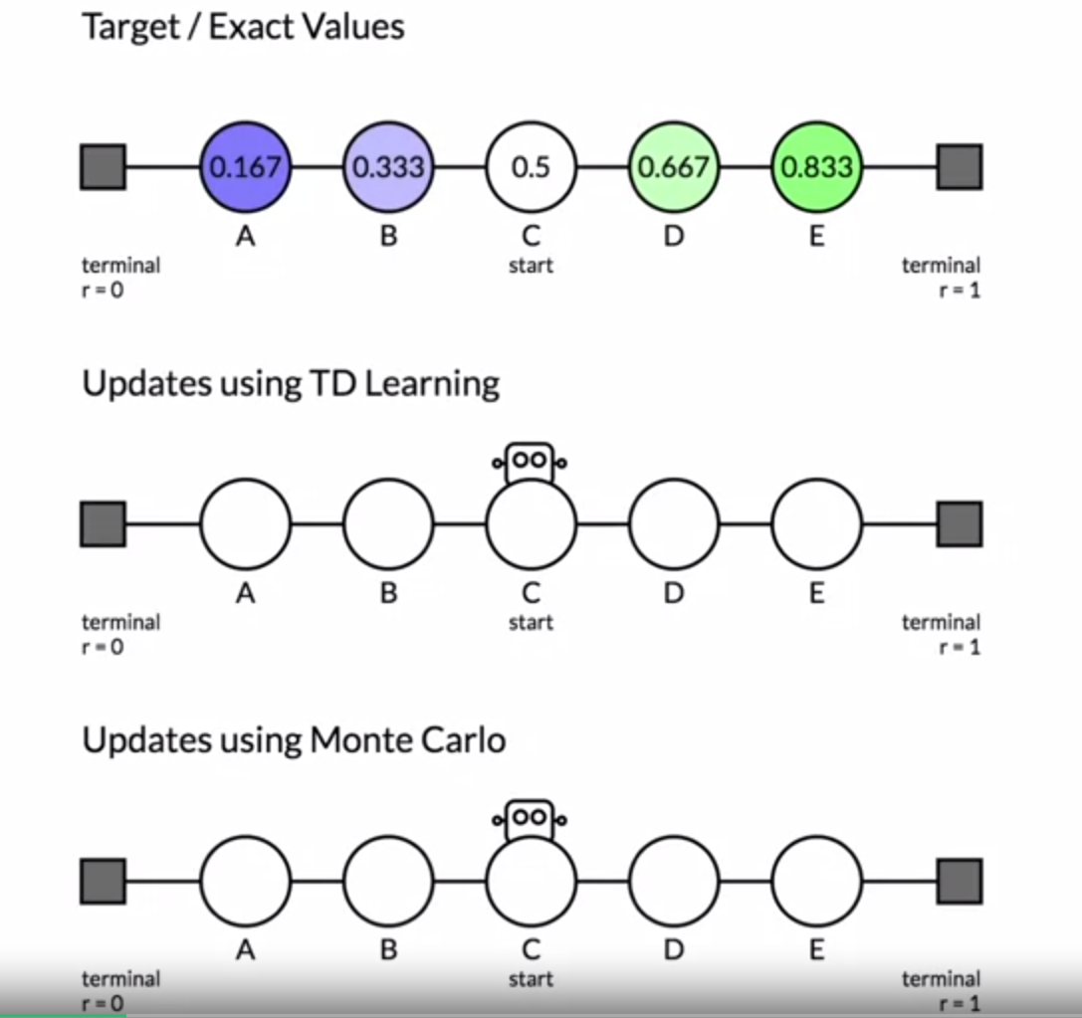
58. .
59. .
60. 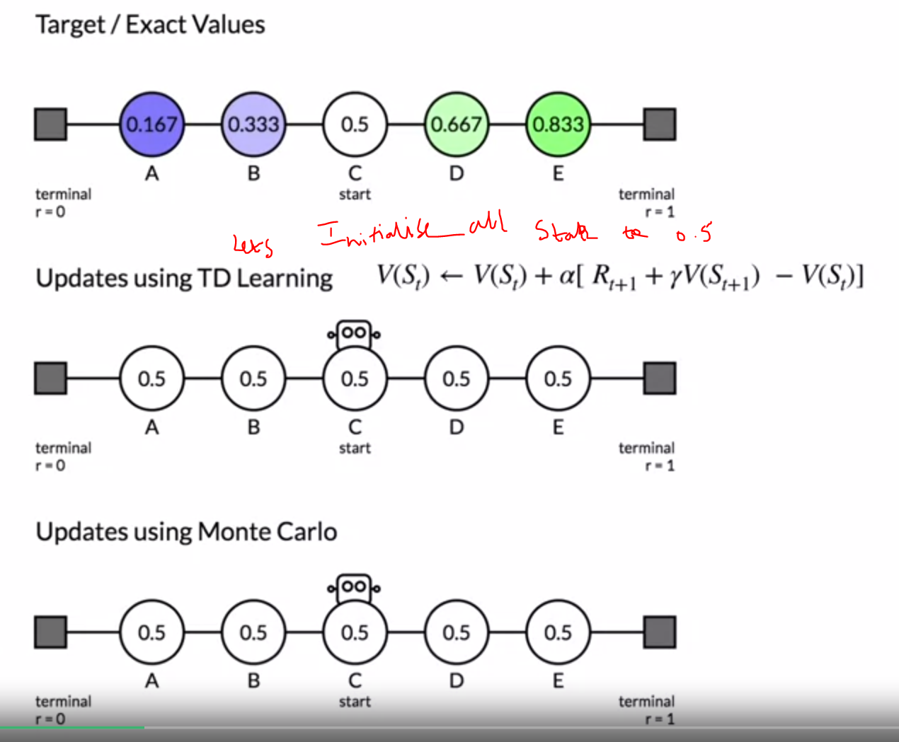
61. .
62. .
63. .
64. 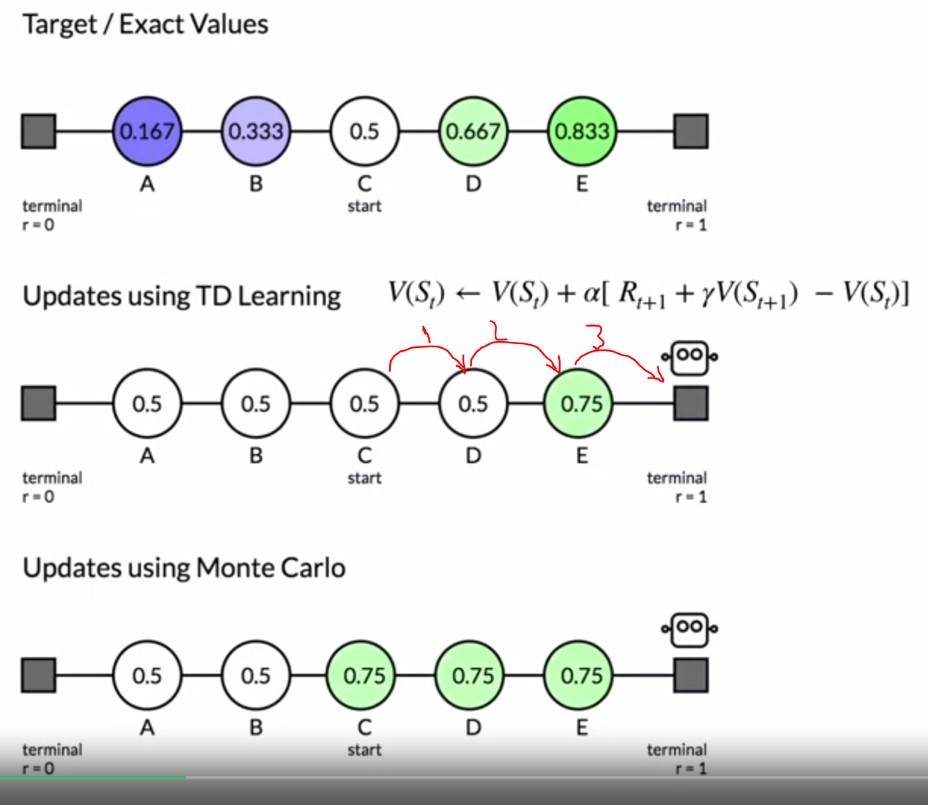
65. .
66. .
67. How in TD moving from C to D impacted
68. .
69. .
70. 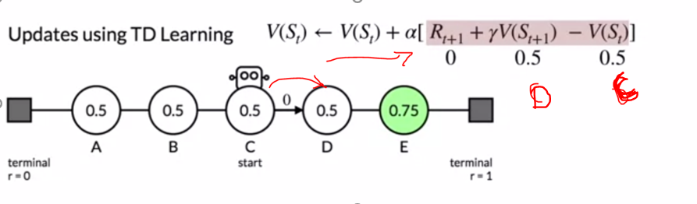
71. .
72. .
73. 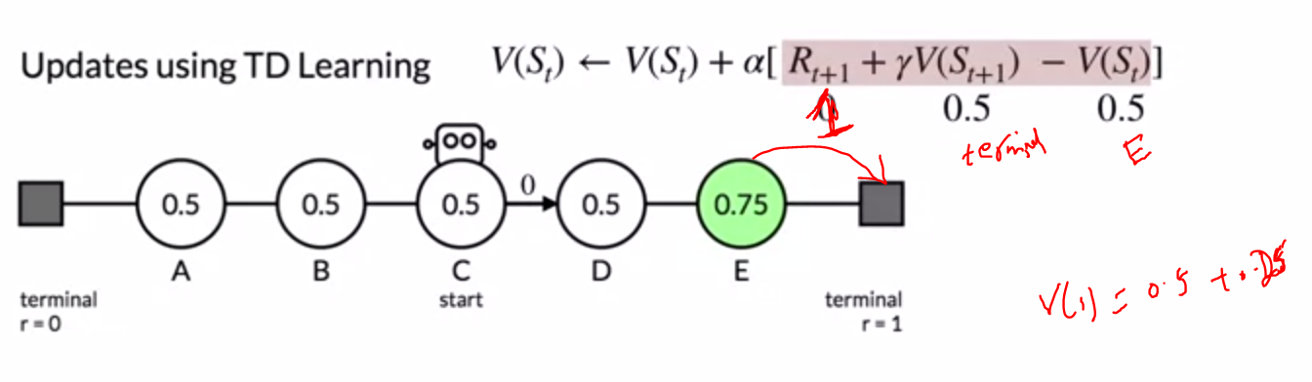
74. .
75. .
76. Note on MC we see all C,D,E got updated to 0.75
77. .
78. .
79. 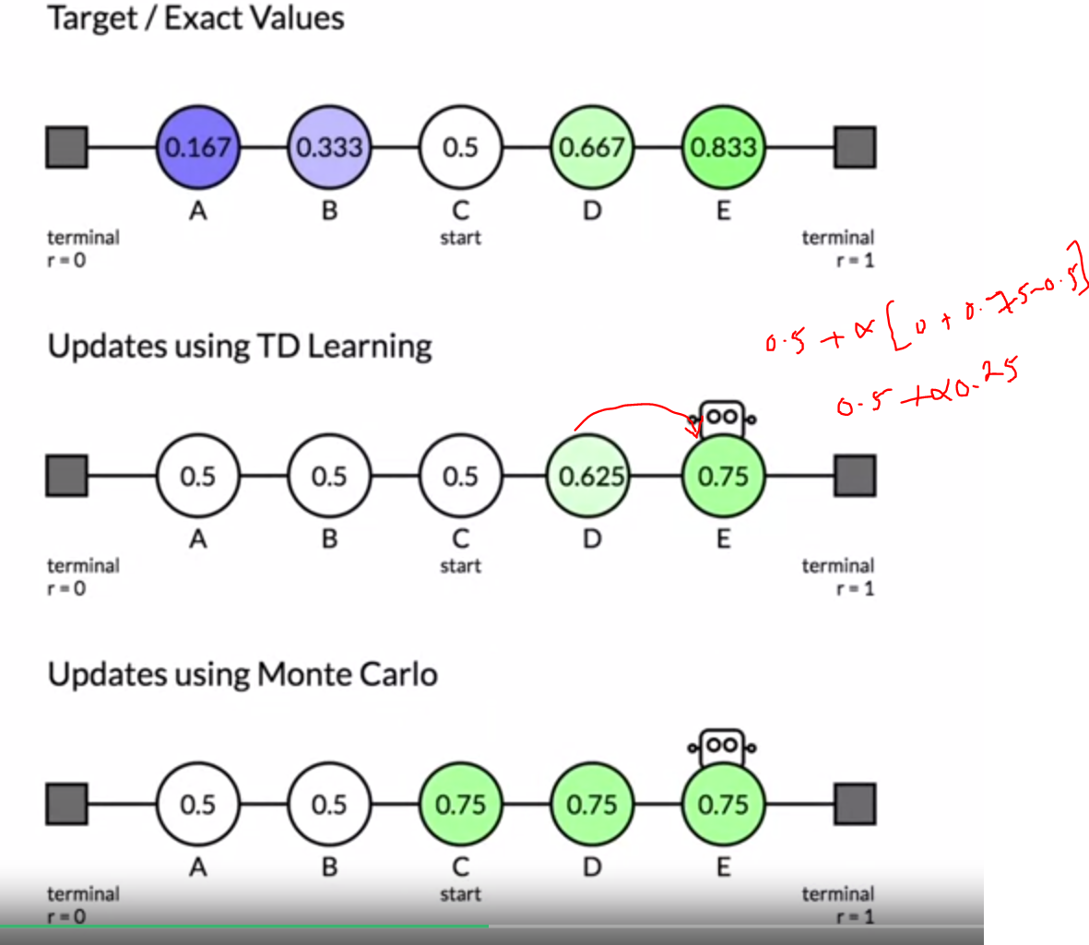
80. .
81. .
82. Now every step gets in TD gets slowly change bacasue of v(s+1)-v(s) is non zero now onwards
83. .
84. .
85. Lets do asysmptotic performance comparison
86. .
87. .
88. .
89. 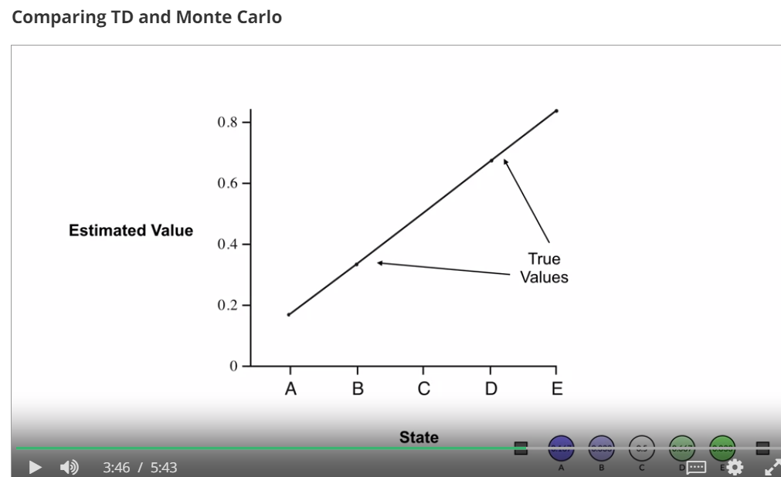
90. .
91. .
92. 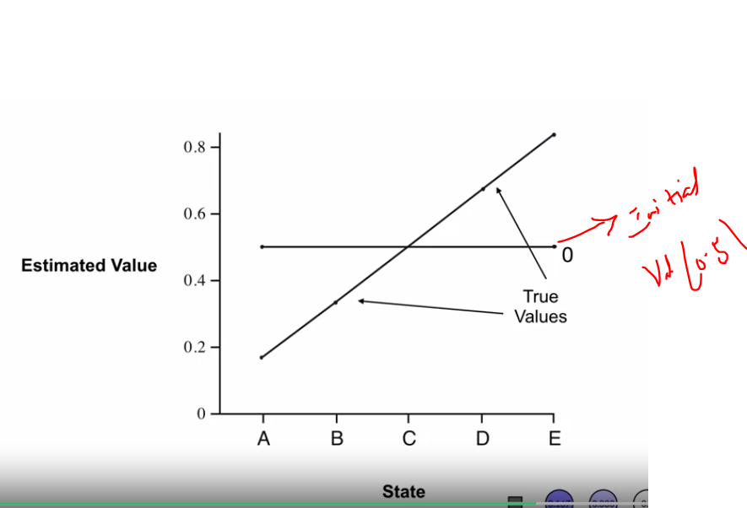
93. .
94. .
95. 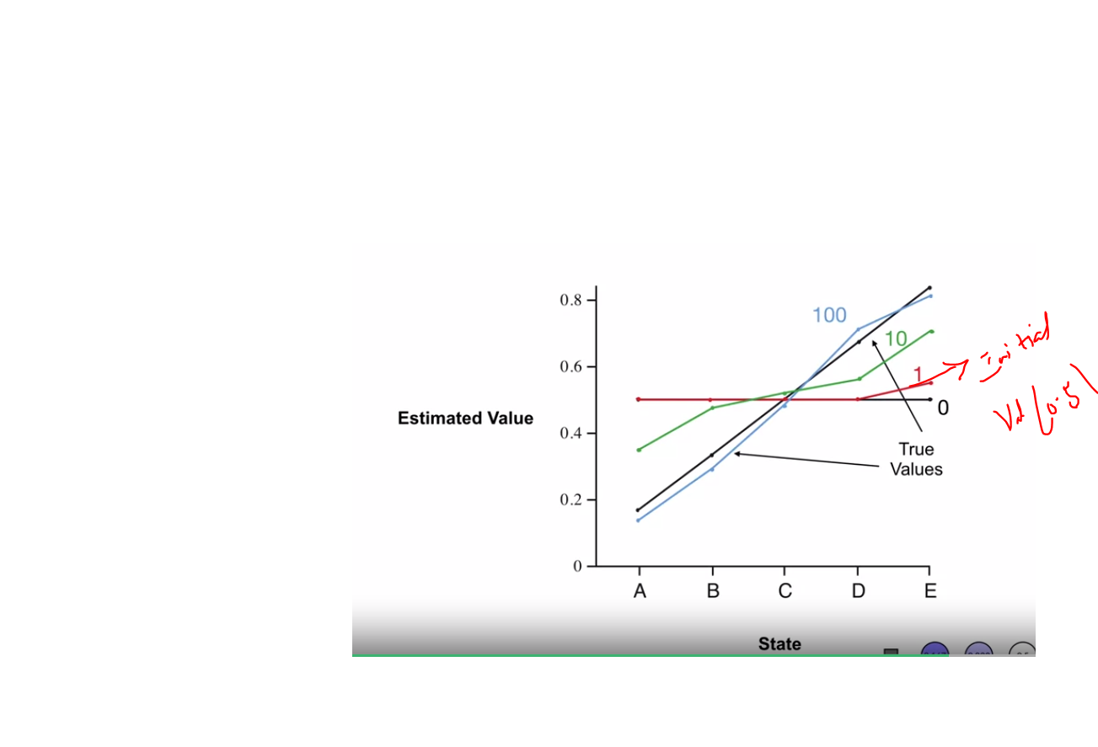
96. .
97. .
98. Constant step size we use =0.1
99. ….
100. Fast compare TD vs MC
101. .
102. ..
103. 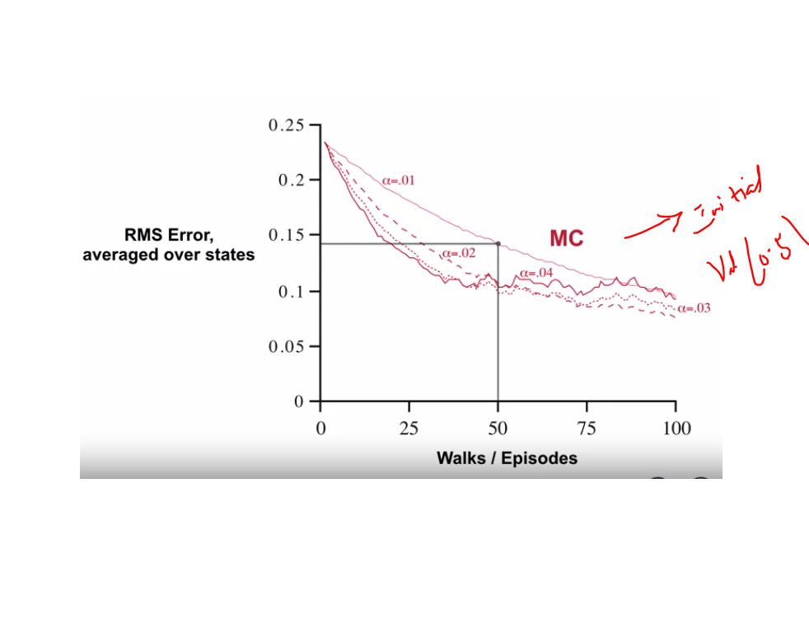
104. 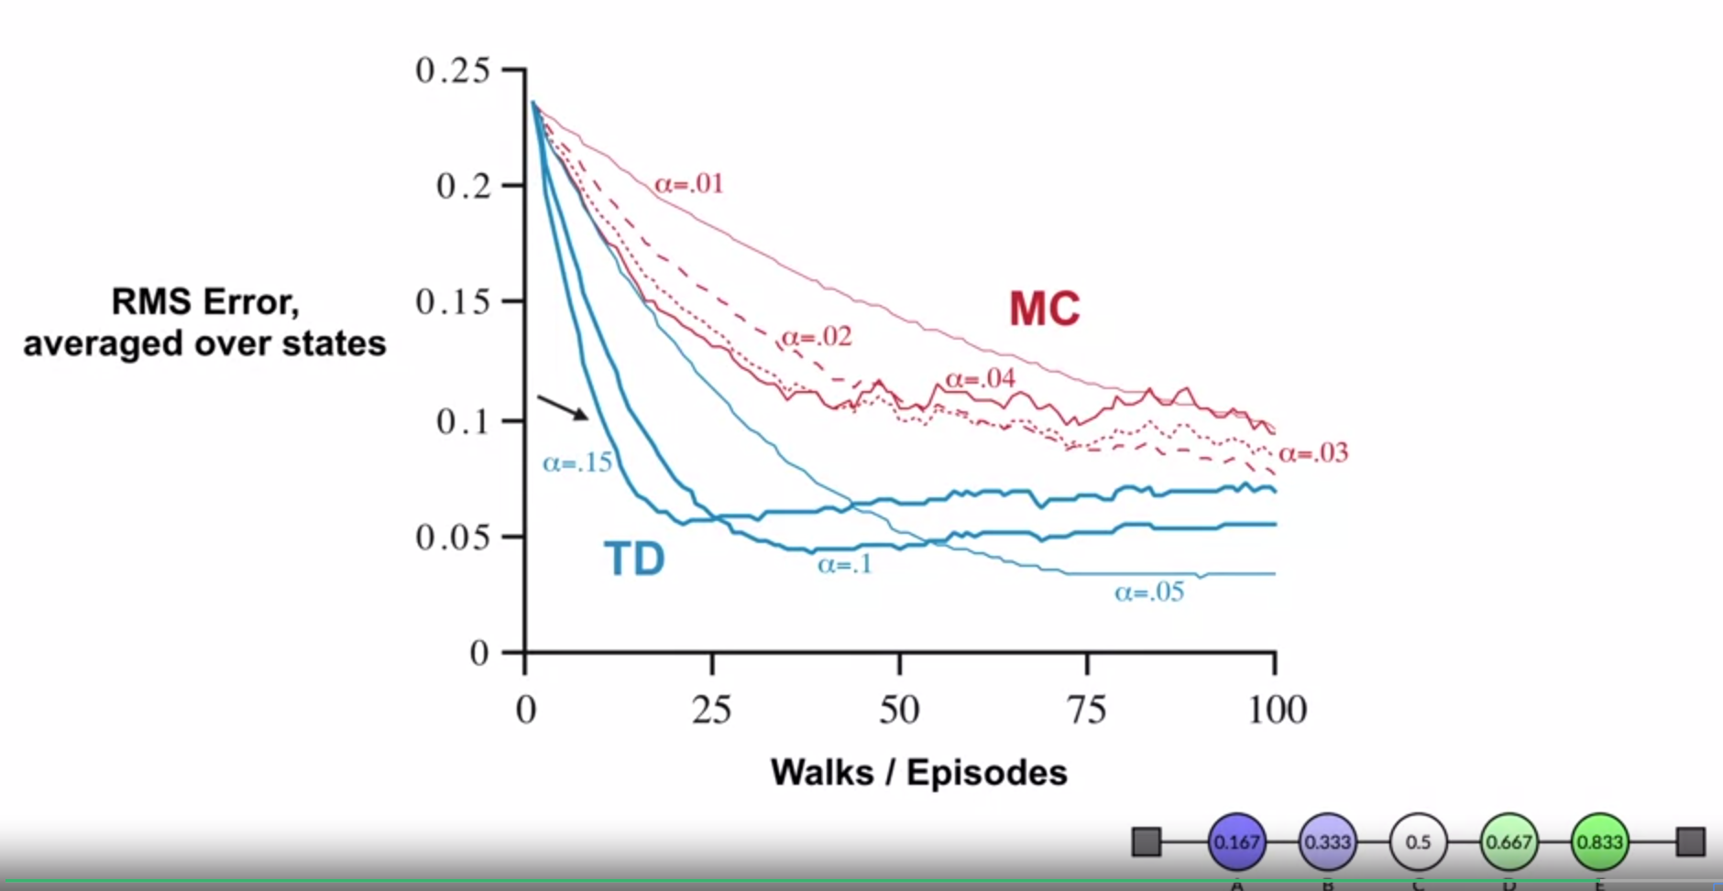
105. .
106. 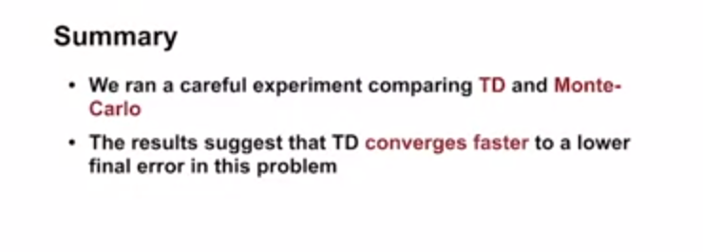.

Summary:

1. 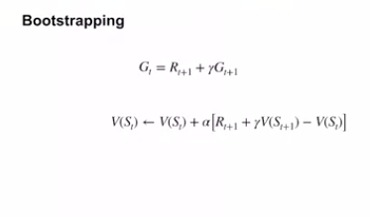
2. .
3. TD updates guess from a guess
4. 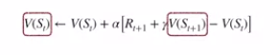
5. .
6. .
7. 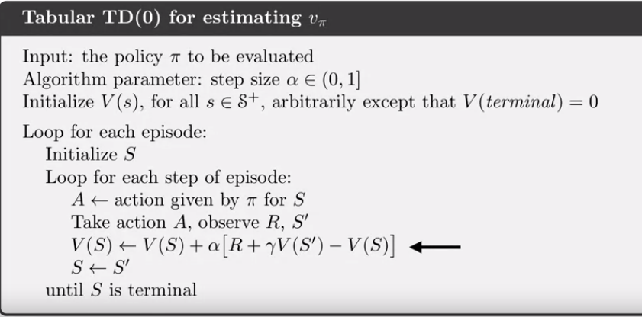
8. .
9. .
10. 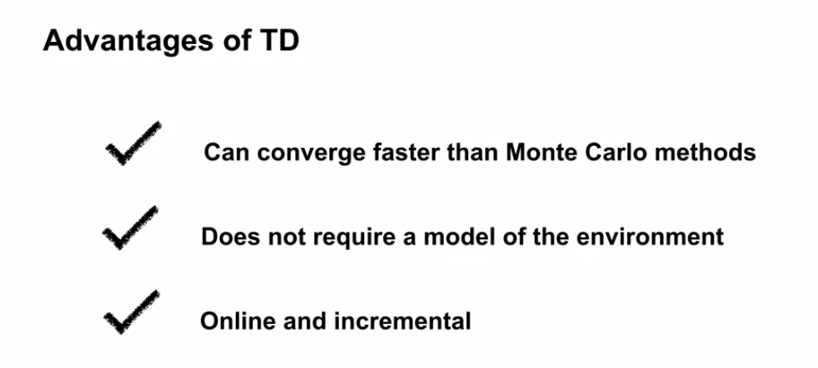
11. .
12. .
13. TD updates its prediction as it received new information
14. .
15. .
16. 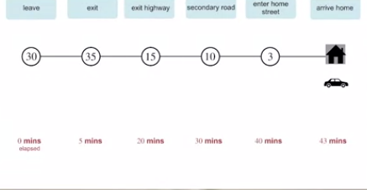

We refined predicted arrival time continuously at every at each dateg of drive way home

Also in random walk example

AT every transition TD updated its value function to reflect most eecent information

On contrast MC updated VF only after episode

Quiz

